Some overview of pandas data frame in jupyter

The Jupyter Notebook
The Jupyter Notebook is an open-source web application that allows you to create and share documents that contain live code, equations, visualizations and narrative text. Uses include: data cleaning and transformation, numerical simulation, statistical modeling, data visualization, machine learning, and much more.

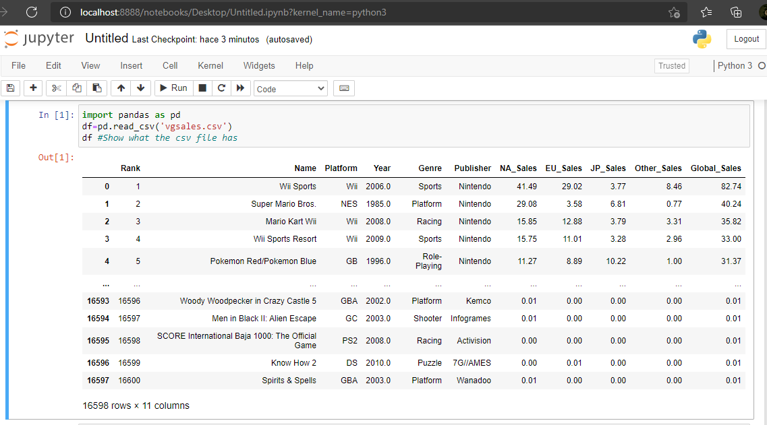

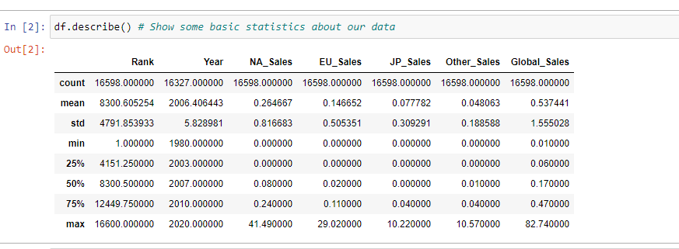

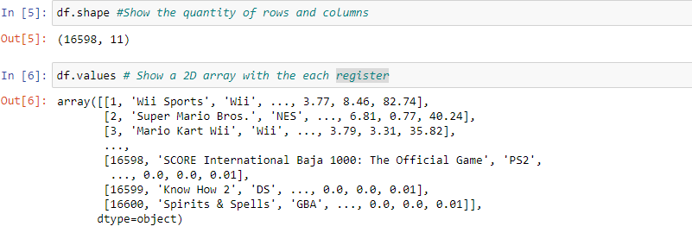
Cleaning the columns to create an input and output which should be the AI response

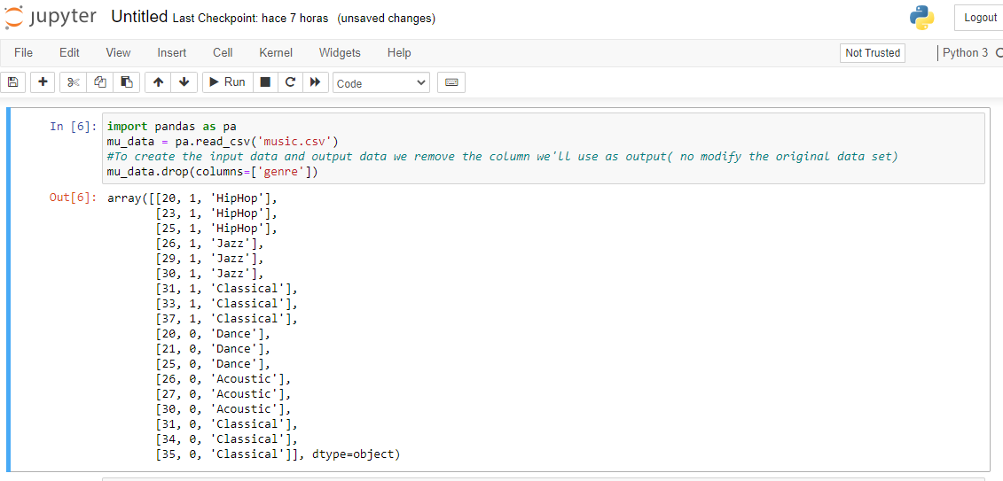
Now we set each data (input and output) to a variable (X and Y)

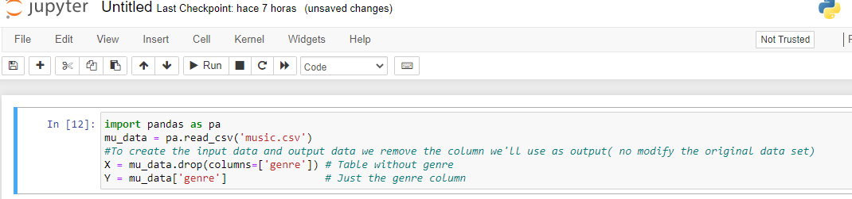

Learning and predicting:

Building a model using a machine learning algorithm, we are going to user decision tree from the library side kick learn.

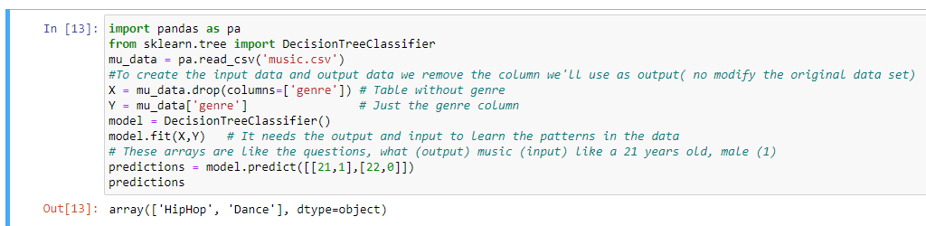

Calculating the accuracy:

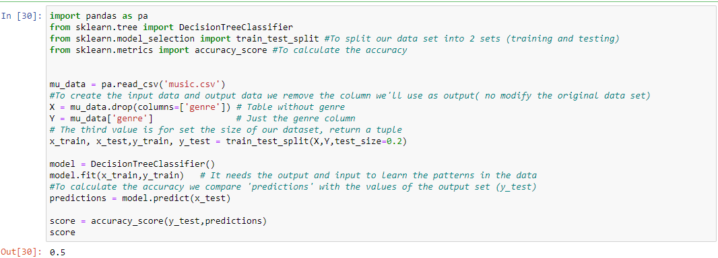
The accuracy would be better if we would have a bigger data file to train the model

Persisting models:
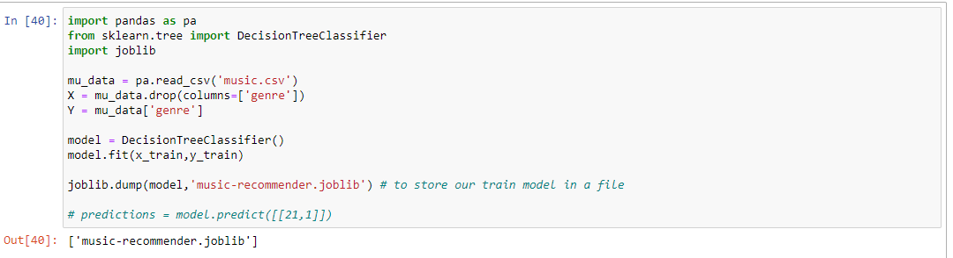
That way we save our model to just load the file and make predictions

That way we persist and load models:
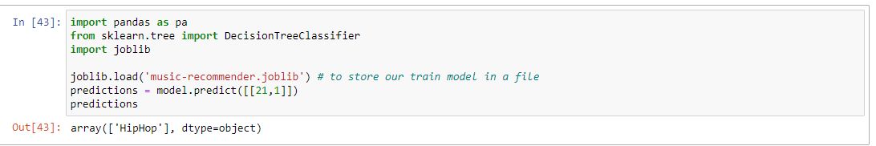

Visualizing a decision tree:

